FRANCIS SAKALA 25/SCA/BCAC/024
DATA STRUCTURE USING C PROGRAMMING
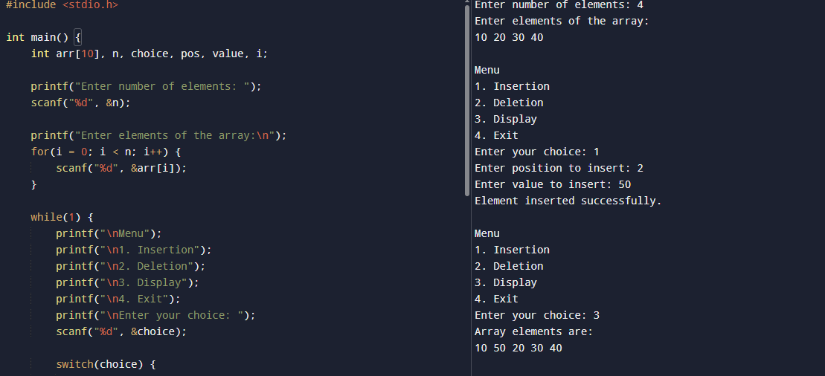
- Array sorting
#include <stdio.h>

int main() {
int arr[10], n, choice, pos, value, i;

printf("Enter number of elements: ");
scanf("%d", &n);

printf("Enter elements of the array:\n");
for(i = 0; i < n; i++) {
scanf("%d", &arr[i]);
}

while(1) {
printf("\nMenu");
printf("\n1. Insertion");
printf("\n2. Deletion");
printf("\n3. Display");
printf("\n4. Exit");
printf("\nEnter your choice: ");
scanf("%d", &choice);

switch(choice) {
case 1:
printf("Enter position to insert: ");
scanf("%d", &pos);
printf("Enter value to insert: ");
scanf("%d", &value);

for(i = n; i >= pos; i--) {
arr[i] = arr[i - 1];
}
arr[pos - 1] = value;
n++;
printf("Element inserted successfully.\n");
break;

case 2:
printf("Enter position to delete: ");
scanf("%d", &pos);

for(i = pos - 1; i < n - 1; i++) {
arr[i] = arr[i + 1];
}
n--;
printf("Element deleted successfully.\n");
break;

case 3:
printf("Array elements are:\n");
for(i = 0; i < n; i++) {
printf("%d ", arr[i]);
}
printf("\n");
break;

case 4:
return 0;

default:
printf("Invalid choice.\n");
}
}
}

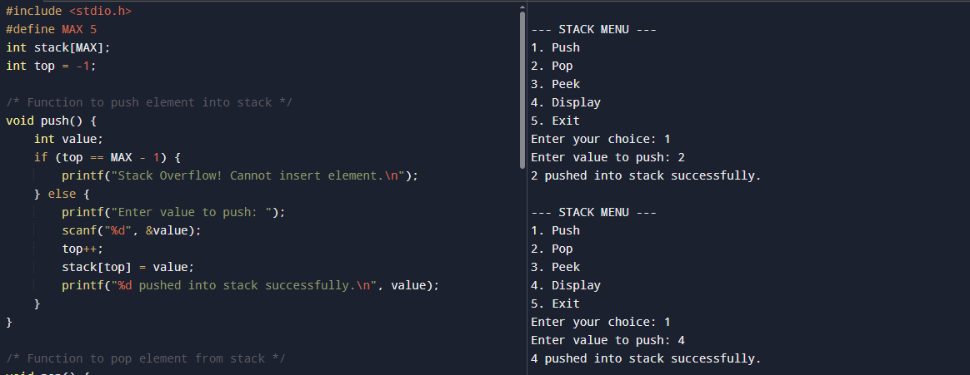
- Stack operation

#include <stdio.h>
#define MAX 5
int stack[MAX];
int top = -1;

/* Function to push element into stack */
void push() {
int value;
if (top == MAX - 1) {
printf("Stack Overflow! Cannot insert element.\n");
} else {
printf("Enter value to push: ");
scanf("%d", &value);
top++;
stack[top] = value;
printf("%d pushed into stack successfully.\n", value);
}
}

/* Function to pop element from stack */
void pop() {
if (top == -1) {
printf("Stack Underflow! Stack is empty.\n");
} else {
printf("%d popped from stack.\n", stack[top]);
top--;
}
}

/* Function to peek top element */
void peek() {
if (top == -1) {
printf("Stack is empty. No top element.\n");
} else {
printf("Top element is: %d\n", stack[top]);
}
}

/* Function to display stack elements */
void display() {
int i;
if (top == -1) {
printf("Stack is empty.\n");
} else {
printf("Stack elements are:\n");
for (i = top; i >= 0; i--) {
printf("%d\n", stack[i]);
}
}
}

int main() {
int choice;

do {
printf("\n--- STACK MENU ---\n");
printf("1. Push\n");
printf("2. Pop\n");
printf("3. Peek\n");
printf("4. Display\n");
printf("5. Exit\n");
printf("Enter your choice: ");
scanf("%d", &choice);

switch (choice) {
case 1:
push();
break;
case 2:
pop();
break;
case 3:
peek();
break;
case 4:
display();
break;
case 5:
printf("Exiting program.\n");
break;
default:
printf("Invalid choice! Please try again.\n");
}
} while (choice != 5);

return 0;
}

- Matrix operation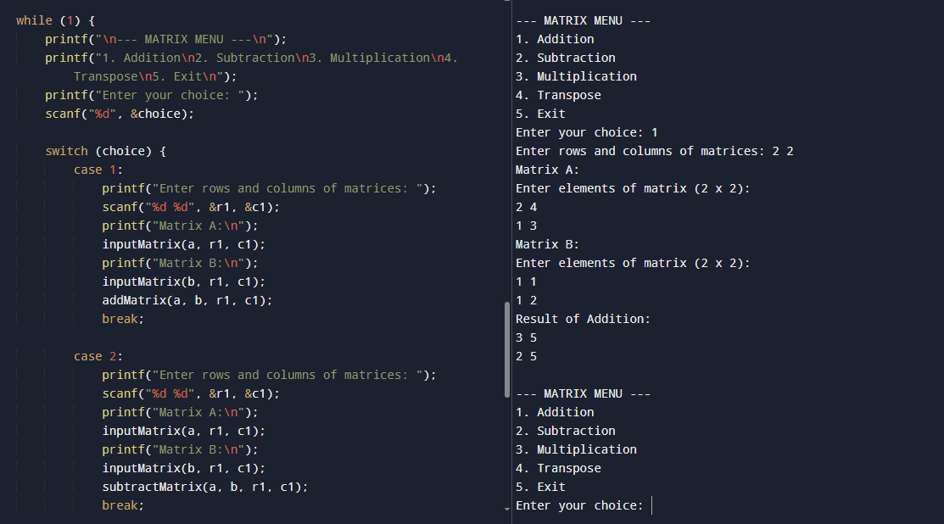
#include <stdio.h>
#include <stdlib.h>

#define MAX 10

// Function to input a matrix
void inputMatrix(int mat[MAX][MAX], int row, int col) {
printf("Enter elements of matrix (%d x %d):\n", row, col);
for (int i = 0; i < row; i++) {
for (int j = 0; j < col; j++) {
scanf("%d", &mat[i][j]);
}
}
}

// Function to display a matrix
void displayMatrix(int mat[MAX][MAX], int row, int col) {
for (int i = 0; i < row; i++) {
for (int j = 0; j < col; j++) {
printf("%d ", mat[i][j]);
}
printf("\n");
}
}

// Matrix Addition
void addMatrix(int a[MAX][MAX], int b[MAX][MAX], int row, int col) {
int sum[MAX][MAX];
for (int i = 0; i < row; i++)
for (int j = 0; j < col; j++)
sum[i][j] = a[i][j] + b[i][j];

printf("Result of Addition:\n");
displayMatrix(sum, row, col);
}

// Matrix Subtraction
void subtractMatrix(int a[MAX][MAX], int b[MAX][MAX], int row, int col) {
int diff[MAX][MAX];
for (int i = 0; i < row; i++)
for (int j = 0; j < col; j++)
diff[i][j] = a[i][j] - b[i][j];

printf("Result of Subtraction:\n");
displayMatrix(diff, row, col);
}

// Matrix Multiplication
void multiplyMatrix(int a[MAX][MAX], int b[MAX][MAX], int r1, int c1, int r2, int c2) {
if (c1 != r2) {
printf("Matrix multiplication not possible (columns of A != rows of B)\n");
return;
}

int prod[MAX][MAX];
for (int i = 0; i < r1; i++) {
for (int j = 0; j < c2; j++) {
prod[i][j] = 0;
for (int k = 0; k < c1; k++) {
prod[i][j] += a[i][k] * b[k][j];
}
}
}

printf("Result of Multiplication:\n");
displayMatrix(prod, r1, c2);
}

// Transpose of a matrix
void transposeMatrix(int mat[MAX][MAX], int row, int col) {
int trans[MAX][MAX];
for (int i = 0; i < row; i++)
for (int j = 0; j < col; j++)
trans[j][i] = mat[i][j];

printf("Transpose of Matrix:\n");
displayMatrix(trans, col, row);
}

// ---------------- MAIN FUNCTION ----------------
int main() {
int choice;
int a[MAX][MAX], b[MAX][MAX];
int r1, c1, r2, c2;

while (1) {
printf("\n--- MATRIX MENU ---\n");
printf("1. Addition\n2. Subtraction\n3. Multiplication\n4. Transpose\n5. Exit\n");
printf("Enter your choice: ");
scanf("%d", &choice);

switch (choice) {
case 1:
printf("Enter rows and columns of matrices: ");
scanf("%d %d", &r1, &c1);
printf("Matrix A:\n");
inputMatrix(a, r1, c1);
printf("Matrix B:\n");
inputMatrix(b, r1, c1);
addMatrix(a, b, r1, c1);
break;

case 2:
printf("Enter rows and columns of matrices: ");
scanf("%d %d", &r1, &c1);
printf("Matrix A:\n");
inputMatrix(a, r1, c1);
printf("Matrix B:\n");
inputMatrix(b, r1, c1);
subtractMatrix(a, b, r1, c1);
break;

case 3:
printf("Enter rows and columns of Matrix A: ");
scanf("%d %d", &r1, &c1);
printf("Matrix A:\n");
inputMatrix(a, r1, c1);

printf("Enter rows and columns of Matrix B: ");
scanf("%d %d", &r2, &c2);
printf("Matrix B:\n");
inputMatrix(b, r2, c2);

multiplyMatrix(a, b, r1, c1, r2, c2);
break;

case 4:
printf("Enter rows and columns of Matrix: ");
scanf("%d %d", &r1, &c1);
inputMatrix(a, r1, c1);
transposeMatrix(a, r1, c1);
break;

case 5:
exit(0);

default:
printf("Invalid choice!\n");
}
}
return 0;
}

- Linear Search and Binary Search
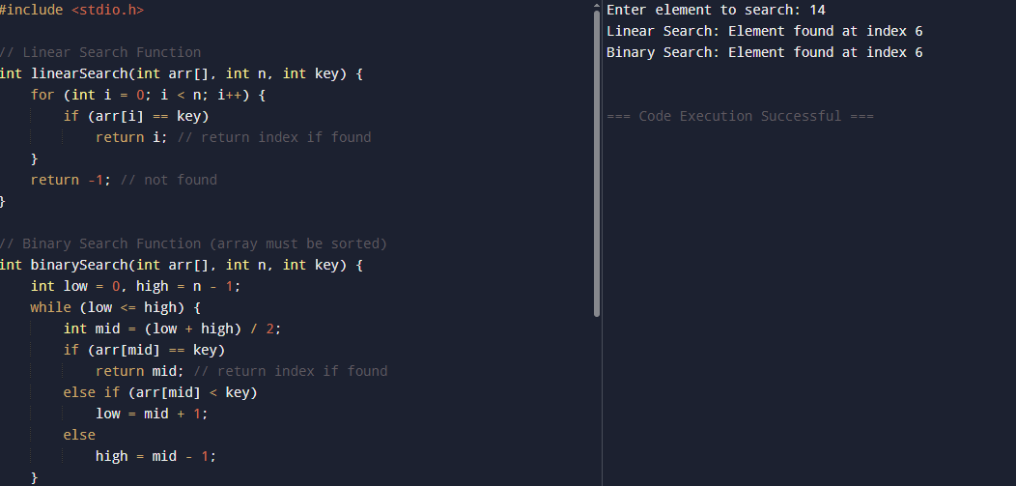

#include <stdio.h>

// Linear Search Function
int linearSearch(int arr[], int n, int key) {
for (int i = 0; i < n; i++) {
if (arr[i] == key)
return i; // return index if found
}
return -1; // not found
}

// Binary Search Function (array must be sorted)
int binarySearch(int arr[], int n, int key) {
int low = 0, high = n - 1;
while (low <= high) {
int mid = (low + high) / 2;
if (arr[mid] == key)
return mid; // return index if found
else if (arr[mid] < key)
low = mid + 1;
else
high = mid - 1;
}
return -1; // not found
}

int main() {
int arr[] = {2, 4, 6, 8, 10, 12, 14};
int n = sizeof(arr) / sizeof(arr[0]);
int key;

printf("Enter element to search: ");
scanf("%d", &key);

// Linear Search
int linearResult = linearSearch(arr, n, key);
if (linearResult != -1)
printf("Linear Search: Element found at index %d\n", linearResult);
else
printf("Linear Search: Element not found\n");

// Binary Search

int binaryResult = binarySearch(arr, n, key);
if (binaryResult != -1)
printf("Binary Search: Element found at index %d\n", binaryResult);
else
printf("Binary Search: Element not found\n");

return 0;}

- STACK OPERATION
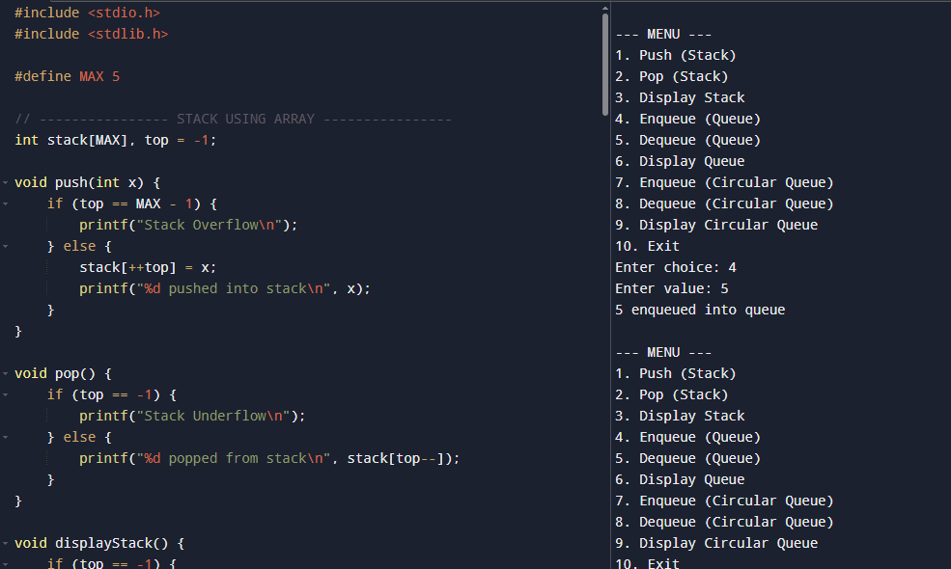

6.POSTFIX operation
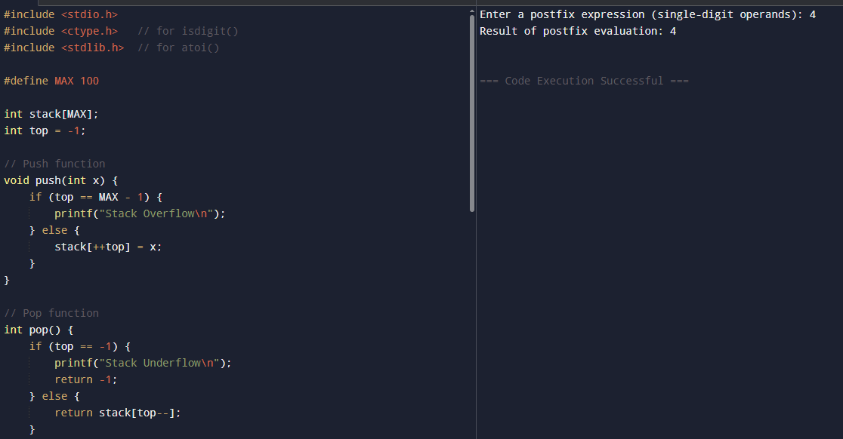
include <stdio.h>
- #include <ctype.h> // for isdigit()
- #include <stdlib.h> // for atoi()

- #define MAX 100

- int stack[MAX];
- int top = -1;

- // Push function
- void push(int x) {
- if (top == MAX - 1) {
- printf("Stack Overflow\n");
- } else {
- stack[++top] = x;
- }
- }

- // Pop function
- int pop() {
- if (top == -1) {
- printf("Stack Underflow\n");
- return -1;
- } else {
- return stack[top--];
- }
- }

- // Function to evaluate postfix expression
- int evaluatePostfix(char *exp) {
- int i = 0;
- while (exp[i] != '\0') {
- // If character is a digit, push it to stack
- if (isdigit(exp[i])) {
- push(exp[i] - '0'); // convert char to int
- }
- // If character is an operator, pop two operands and apply operator
- else {
- int val2 = pop();
- int val1 = pop();
- switch (exp[i]) {
- case '+': push(val1 + val2); break;
- case '-': push(val1 - val2); break;
- case '*': push(val1 * val2); break;
- case '/': push(val1 / val2); break;
- }
- }
- i++;
- }
- return pop(); // Final result
- }

- int main() {
- char exp[MAX];
- printf("Enter a postfix expression (single-digit operands): ");
- scanf("%s", exp);

- int result = evaluatePostfix(exp);
- printf("Result of postfix evaluation: %d\n", result);

- return 0;
- }

7. INFIX OPERATION
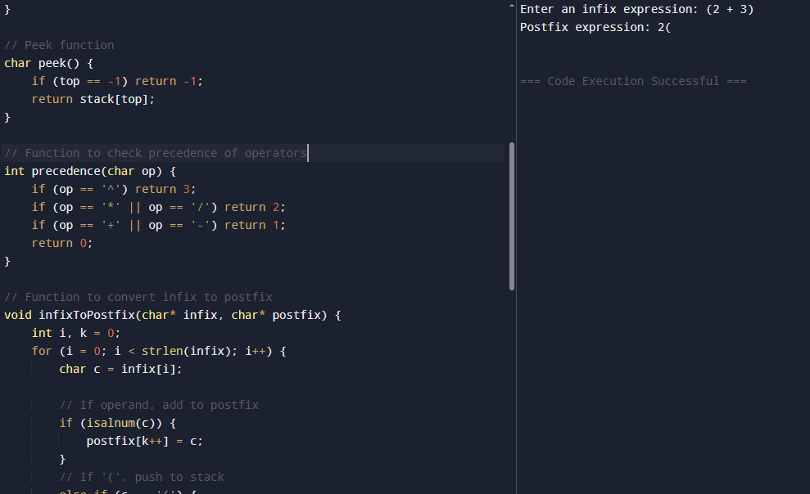
#include <stdio.h>
#include <ctype.h> // for isalnum()
#include <string.h> // for strlen()

#define MAX 100

char stack[MAX];
int top = -1;

// Push function
void push(char c) {
if (top == MAX - 1) {
printf("Stack Overflow\n");
} else {
stack[++top] = c;
}
}

// Pop function
char pop() {
if (top == -1) {
return -1;
} else {
return stack[top--];
}
}

// Peek function
char peek() {
if (top == -1) return -1;
return stack[top];
}

// Function to check precedence of operators
int precedence(char op) {
if (op == '^') return 3;
if (op == '*' || op == '/') return 2;
if (op == '+' || op == '-') return 1;
return 0;
}

// Function to convert infix to postfix
void infixToPostfix(char* infix, char* postfix) {
int i, k = 0;
for (i = 0; i < strlen(infix); i++) {
char c = infix[i];

// If operand, add to postfix
if (isalnum(c)) {
postfix[k++] = c;
}
// If '(', push to stack
else if (c == '(') {
push(c);
}
// If ')', pop until '('
else if (c == ')') {
while (top != -1 && peek() != '(') {
postfix[k++] = pop();
}
pop(); // remove '('
}
// If operator
else {
while (top != -1 && precedence(peek()) >= precedence(c)) {
postfix[k++] = pop();
}
push(c);
}
}

// Pop remaining operators
while (top != -1) {
postfix[k++] = pop();
}

postfix[k] = '\0'; // null terminate string
}

int main() {
char infix[MAX], postfix[MAX];

printf("Enter an infix expression: ");
scanf("%s", infix);

infixToPostfix(infix, postfix);

printf("Postfix expression: %s\n", postfix);

return 0;
}

